**APPLICATION OF MANAGEMENT THEORIES AND PRACTICES IN *SHAN FOODS PVT LTD COMPANY***

**DECLARATION**

We, the undersigned, affirm that the report titled *“Application of Management Theories and Practices in Shan Foods (Pvt.) Ltd.”* is an original work submitted in partial fulfillment of the requirements for the course *Fundamentals of Management*. We confirm that this report has not been copied from any source and is free from plagiarism beyond the accepted academic threshold of 20%.

All materials or data used from secondary sources have been duly acknowledged and cited. Furthermore, we declare that this report has not been submitted previously to any other institution or university for any academic purpose.

**SUBMITTED BY:**

1. Rana Hamad **Roll** # 23F-0662
2. Shawaiz Shahid **Roll** # 23P-0599
3. Muhammad Hamza **Roll** # 23P-0577
4. Waleed Afzal **Roll** # 23P-0566
5. Arsal Hassan **Roll** # 22F-3384

__________________________________________________________________

**ACKNOWLEDGEMENT:**

First of all, we would like to sincerely thank **Dr. Misbah Hayat Bhatti**, our respected instructor for the Fundamentals of Management course, for giving us the opportunity to work on this project. We are truly grateful for her continuous support, valuable advice, and guidance throughout the project.

We are also thankful to the management and staff of **Shan Foods** for making important information publicly available, which greatly helped us in preparing this report.

We extend our appreciation to our families and friends for their constant encouragement and support during this project.

Finally, we would like to thank each member of our team for their hard work, dedication, and cooperation in completing this report with honesty and commitment.

**CERTIFICATION FROM GUIDE**

This is to certify that this project entitled **“Application of Management Theories and Practices in SHAN FOOD PVT LTD”** submitted in partial fulfilment of the course strategic Fundamental of Management to **Dr Misbah Hayat Bhatti**, done by:

**Mr**./Ms. Rana HamadRoll # 23F-0662

**Mr**./Ms. Shawaiz Shahid Roll # 23P-0599

**Mr**./Ms. Waleed AfzalRoll # 23P-0566

**Mr**./Ms. Muhammad Hamza Roll # 23P-0577

**Mr**./Ms. Arsal HassanRoll # 22P-3384

**TABLE OF CONTENTS**

1. Title Page & Declaration & Acknowledgement
2. Certification From Guide
3. Table of Contents
4. Short Description of Company
   1. Company Overview
   2. Business Operations
   3. Market and Competitors
5. Planning
   1. Vision
   2. Mission
   3. Goals (Strategic, Real vs Financial)
   4. Plans (Strategic vs Operation, Long Term vs Short Term Directional vs Specific, Single vs Standing)
   5. Type Of Strategies Organization pursues its goals
   6. SWOT & PESTEL Analysis
   7. BCG Matrix & Porter 5 Forces
6. Organizing
   1. Organization Structure
   2. Number of Employees and Departments
   3. Forms of Departmentalization
   4. Organizational Structure and Alignment
7. Leading & Motivating
   1. Role of Leadership
   2. Motivational Practices
   3. Incentives and Benefits
   4. Leadership Style
8. Controlling  
   8.1 Controlling Processes

8.2 Employee Progress Monitoring

8.3 Benchmarking Practices

**9**. Conclusion

**COMPANY OVERVIEW**

Shan Foods is a Pakistani food company. It was founded in 1981 by Sikandar Sultan​. The company’s head office is in Karachi, Pakistan​. Shan Foods makes and sells packaged spice mixes and ready-cook food products (like curry mixes and sauces) used in South Asian dishes​.

* **Founded:** 1981 (by Sikandar Sultan)​
* **Head office:** Karachi, Pakistan​
* **Main business:** Producing spice and recipe mixes (packaged blends), cooking sauces and other food products for home cooking​

**BUSINESS OPERATIONS**

Shan Foods produces many kinds of spices and recipe mixes. Its product range includes recipe mixes for dishes (e.g. biryani, tikka, korma), plain spices (like salt and chili), cooking sauces and pastes, pickles and condiments, dessert mixes, and instant noodles. All products are made at its factories in Karachi (Korangi Industrial Area)​.

* **Product range:** Recipe spice mixes, plain spices, cooking sauces/pastes, pickles and other condiments, dessert mixes, lentils, and instant noodles​.
* **Departments:** The company has Production, Marketing, Sales and Distribution teams, and also a Research & Development (R&D) department that creates new recipes​. It also has a Quality Control department to inspect products at each stage​.
* **Quality standards:** Shan Foods says it follows strict international quality and hygiene standards in its manufacturing​. Products are made and packed under clean, hygienic conditions and are checked with regular audits and tests.
* **Manufacturing:** All products are made in its Karachi factory​. The company uses modern food-processing methods (e.g. special grinding technology) to keep spices fresh.
* **Exports:** Shan Foods exports its products to many countries around the world (see below), so it has departments for international sales and distribution as part of its operations.

**MARKET AND COMPETITORS**

Shan Foods sells in Pakistan and in many other countries. Its products are available across Asia, the Middle East, North America, Europe and beyond. For example, one news report noted Shan Foods spice mixes are sold in 65 countries (including India)​. The company’s own profile says its products reach over 150 countries on five continents​.

* **Markets:** Domestic (all of Pakistan) and international (Asia, Middle East, North America, Europe, etc.)​.
* **Local competitors:** In Pakistan, the main competitor is **National Foods**, which has an even larger market share​. Other local spice brands (like Chef’s Pride) also compete in the same market.
* **Competition factors:** Shan Foods competes on product quality and brand. Its rivalry with National Foods is driven by factors like authentic taste, product quality, pricing, and marketing strategy​. (In other markets, it faces local spice brands and big global spice companies.)
* **Brand and pricing:** Shan is known for authentic Pakistani flavors and quality. It is priced competitively and builds its brand on strong flavor and reliable quality to win customers.

**Chapter # 01**

1. **Planning in SHAN FOODS PVT LTD**

Planning at Shan Foods is all about setting clear goals and objectives for the company and thinking about different ways to achieve them. It also includes preparing for unexpected challenges that might come in the future.  
In simple words, it means making smart plans today to stay strong tomorrow.

For Shan Foods, planning focuses on growing the company into new international markets, introducing new food products, and staying ahead in the very competitive food industry. They plan carefully to keep their traditional taste alive while also offering easy and modern food solutions for busy lifestyles.  
Their planning also covers how to deal with global challenges like changing customer preferences, new health trends, and international trade rules.

**1.1 Vision Statement:**

**Vision** is what the company dreams to become in the future.  
It gives direction and inspiration.

**Shan Foods Vision:**  
"To become a leading global food company offering authentic and convenient food solutions."

(Meaning: Shan wants to be one of the top food brands in the world by giving real, authentic taste in easy-to-use products.)

* 1. **Mission Statement:**

**Mission** is what the company is doing *right now* to achieve its vision.  
It explains the company’s purpose and main activities.

**Shan Foods Mission:**  
"To provide our customers with quality products that offer authentic taste and convenience, bringing traditional flavors to every table."

(Meaning: Shan focuses on making quality products that are easy to cook but taste like homemade traditional food.)

**1.3 Goals:**

**Goals** are what the company wants to achieve.  
There are two types:

* **Strategic Goals:**
  + Become a top global brand in spices and recipe mixes.
  + Expand into new international markets (like Africa and South America).
* **Real Goals (Practical):**
  + Maintain high product quality.
  + Increase customer loyalty and trust.
* **Financial Goals:**
  + Increase yearly sales revenue by 10–15%.
  + Improve profit margins through better production and distribution.
  1. **Plans:**

**Plans** are the steps to reach the goals.  
There are different types:

* **Strategic Plans:** (Big, long-term plans)
  + Expand Shan's product range (e.g., instant noodles, cooking sauces).
  + Open new markets globally.
* **Operational Plans:** (Daily/weekly work)
  + Improve production line efficiency.
  + Launch a new marketing campaign this year.
* **Long Term Plans:** (More than 3 years)
  + Open factories outside Pakistan (maybe in the Middle East).
* **Short Term Plans:** (Within 1 year)
  + Introduce 5 new recipe mixes.
* **Directional Plans:**
  + Focus on making Shan a household brand name in every Pakistani kitchen worldwide.
* **Specific Plans:**
  + Launch a special 'Ramazan Product Bundle' campaign by next year.
* **Single Use Plan:**
  + Open a special store for Shan Foods’ 45th anniversary celebration.
* **Standing Plan:**
  + Always maintain ISO certified quality standards in every batch.

**1.5 Types of Strategies Organization Pursue its Goals:**

Shan Foods uses different strategies like:

* **Growth Strategy:**
  + Introducing new products (e.g., instant noodles) and expanding to new countries.
* **Stability Strategy:**
  + Keeping their spice mix market strong in Pakistan and not changing much in already successful areas.
* **Differentiation Strategy:**
  + Offering special, authentic, traditional flavors that competitors can't easily copy.
* **Cost Leadership (Sometimes):**
  + Offering good quality at reasonable prices to beat competitors.

**1.6 SWOT Analysis:**

|  |  |
| --- | --- |
| Strengths | Weaknesses |
| Strong Brand Recognition | High Competition with National Foods |
| Wide Variety of Products | Heavy Dependency on the Spice Market |
| Global Presence | Limited direct-to-customer shop |
| Opportunities | Threats |
| Expanding Health-Conscious food items | Changing International trade policies |
| Growing International Markets | Fluctuating raw materials prices |

**1.7 PESTEL Analysis:**

|  |  |
| --- | --- |
| Factor | Impact On SHAN FOODS |
| Political | Changes in trade/export policies can affect Shan's international business |
| Economic | Inflation can increase production costs. |
| Social | Demand for authentic, traditional food is rising. |
| Technological | New food packaging technologies improve product life. |
| Environmental | Need for eco-friendly packaging due to global environmental concerns |
| Legal/Laws | Food safety regulations in different countries must be followed. |

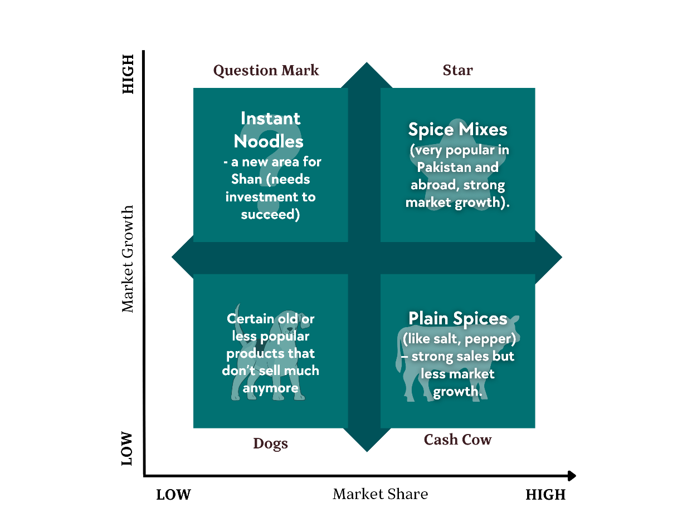 **1.8 BCG Matrix:**

The **BCG Matrix** is a tool that helps companies like Shan Foods understand which of their products are performing well and which need more attention.

It divides products into four types:

* ⭐ **Stars**
* 🐄 **Cash Cows**
* ❓ **Question Marks**
* 🐶 **Dogs**

**1.9 Porter’s Five Forces:**

|  |  |
| --- | --- |
| Force | Impact On SHAN FOODS |
| Competitive Rivalry | High (because of National Foods and others). |
| Threat of New Entrants | Medium (new spice brands can enter easily. |
| Threat of Substitutes | Medium (homemade spices or other brands). |
| Bargaining Power of Suppliers | Low (many suppliers available). |
| Bargaining Power of Customers | High (customers can easily switch brands). |

**Chapter # 02**

1. **ORGANIZING IN SHAN FOODS:**

Shan Foods follows a **formal and organized structure**.  
The company has a **hierarchical** structure, meaning there are clear levels of management from top to bottom.  
At the top is the **CEO** who takes major decisions, and under him, there are heads of different departments like Marketing, Production, Finance, HR, and International Business.

Each department head manages their own teams and reports directly to senior management.  
This structure helps Shan Foods make decisions faster and clearly divide responsibilities.

**2.1 ORGANIZATION STRUCTURE – ORGANOGRAM:**

Shan Foods follows a Top-to-Bottom (Top-Down) organizational structure.

* Top-Down structure means that decisions start from the top leaders (like CEO and department heads) and then move down to managers and employees.
* Orders, plans, and strategies are first made by senior management, and then they are passed down to the lower levels for execution.
* Each level of the company reports to the level above.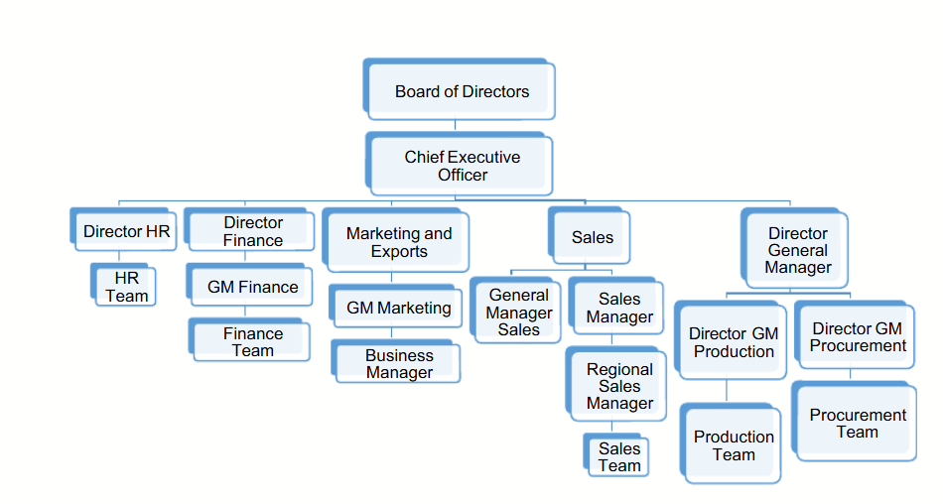

**2.2 NUMBER OF EMPLOYEES AND DEPARTMENTS:**

* Shan Foods has **over 1000 employees**.
* They work in different departments such as:
  + **Production Department** (where food products are made)
  + **Quality Control Department** (ensures food is safe and high quality)
  + **Marketing and Sales Department** (promotes products and manages sales)
  + **Finance Department** (handles money and budgets)
  + **Human Resource Department** (manages employee hiring, training, and policies)
  + **Research and Development (R&D) Department** (creates new products and improves recipes)
  + **Export/International Business Department** (handles global sales and shipping)

Each department plays an important role in the success of Shan Foods.

**2.3 DEPARTMENTALIZATION AT SHAN FOODS:**

Shan Foods uses a combination of different forms of departmentalization, but the most prominent is:

**Functional Departmentalization**

This is because Shan Foods organizes its major activities by specialized functions, like:

* **Production Department** (manufacturing spices and food products)
* **Marketing Department** (branding and advertising)
* **Finance Department** (handling budgets, payments, and accounts)
* **Human Resources** (HR) (managing employees and recruitment)
* **Research & Development** (R&D) (creating and improving products)  
  Each function has a team focused on that specific task for better efficiency.

**Other Forms Used:**

* **Geographical Departmentalization –**➔ Because Shan Foods operates internationally (Middle East, USA, UK, Canada, Australia, etc.), they have regional export teams and marketing customized for different areas.
* **Product-based Departmentalization –**➔ Different teams manage different product lines like Recipe Mixes, Plain Spices, Desserts, Pickles, and Sauces.
* **Process-based Departmentalization –**➔ In manufacturing units, different teams handle different stages like blending, packaging, labeling, and quality control.

**2.4 SHAN FOODS ORGANIZATIONAL STRUCTURE – USING SIX ELEMENTS:**

Let’s explore **Shan Foods’ structure** using the six elements of organizational design:

|  |  |
| --- | --- |
| Element | Explanation In SHAN FOODS Context |
| Work Specialization | |  | | --- | | High – Employees have very specific jobs like product development, marketing, or quality control. |  |  | | --- | |  | |
| Departmentalization | Mostly Functional Separate departments for Production, Marketing, HR, etc. Some Product-based and Geographical also. |
| Chain of Command | |  | | --- | | Clear – From CEO to department heads to employees. |  |  | | --- | |  | |
| Span Of Control | Moderate – Managers handle 6–12 employees. |
| Centralization | Mixed – Big decisions made by top management. |

**2.5 ALIGNMENT WITH EXTERNAL ENVIRONMENT:**

Shan Foods’ structure is **well aligned with the external market**.  
They **quickly adapt** to customer preferences, international food regulations, and market trends.  
Because they export to over **65 countries**, they have a **flexible structure** — top management makes major brand decisions (centralized), but **local teams** in different regions adjust marketing and product flavors according to the local culture (decentralized).

Their **strong formal policies** help maintain **high quality** worldwide, while their **local responsiveness** keeps them competitive in changing markets like the Middle East, Europe, and North America.

**Chapter # 03**

1. **LEADING & MOTIVATING AT SHAN FOODS COMPANY:**

Leadership and motivational practices are very important for reaching the goals of the organization, and employees must stay dedicated and energetic. Shan Foods understands that its employees are its greatest strength and therefore focuses a lot on leading and motivating them. The company invests in different programs and activities to make sure the workforce stays motivated and aligned with the company’s vision. In this section, we will explain the leadership styles used at Shan Foods, the motivational practices followed, and the different incentives given to employees to keep them highly engaged and committed.

**3.1 ROLE OF LEADERS IN RETAINING MOTIVATED EMPLOYEES:**

At Shan Foods, leadership is not just about giving directions but also about keeping employees motivated, engaged, and focused on achieving the company's goals. Leaders at Shan Foods play important roles such as:

❖ **Communicating a clear vision:** Leaders at Shan Foods clearly share the company’s goals for growth, product innovation, and expansion into new markets. This helps employees feel excited and involved in the company's journey.  
❖ **Global Expansion Vision:** Shan Foods is focusing on becoming a strong global brand, reaching more countries and cultures by offering a wide variety of quality food products.  
❖ **Commitment to Innovation:** Shan leaders encourage new ideas for improving products, packaging, and production processes to stay ahead in the highly competitive food industry.  
❖ **Sustainability Focus:** Shan promotes sustainable practices like eco-friendly packaging and responsible sourcing, showing employees that they are part of a company that cares for the environment.  
❖ **Community Engagement:** Shan Foods supports charity programs and community projects, motivating employees by connecting their work to a bigger purpose beyond just business success.

**3.2 MOTIVATIONAL PRACTICES:**

Shan Foods uses a mix of intrinsic and extrinsic motivational practices to keep its employees energetic, happy, and committed:

**Intrinsic Motivation Practices**

• **Autonomy:** Employees are given freedom to share ideas and take part in creative projects to improve products and operations.

* **Innovation Programs:** Shan encourages employees to suggest new recipes, improve packaging designs, and recommend ways to make processes better, helping employees feel valued and creative.

• **Purpose:** Employees feel proud knowing they are part of a company that brings authentic tastes of Pakistan to the world and supports communities through social programs.

* **Global Impact:** By offering traditional Pakistani spices and foods internationally, employees feel connected to promoting cultural pride and spreading local flavors worldwide.

• **Skill Development:** Shan Foods provides training sessions and workshops to help employees improve their professional skills.

* **Learning Opportunities:** Employees can attend leadership programs, marketing skill sessions, and technical training to grow in their careers and feel more confident.

**Extrinsic Motivation Practices**

• **Regular Feedback:** Managers give regular feedback to employees to help them know their strengths and areas for improvement, boosting motivation and growth.

* **Annual Reviews and Check-ins:** Employees meet with their managers at least once a year (plus informal feedback sessions) to discuss performance, goals, and achievements.

• **Recognition Programs:** Shan celebrates employee achievements through awards, shout-outs during meetings, and special rewards like certificates and small gifts.

* **Employee Appreciation Events:** Special events like "Employee of the Month" and celebration days are organized to recognize hard work and dedication.

**3.3 INCENTIVES AND BENEFITS:**

Shan Foods offers different financial and non-financial incentives to keep employees motivated and committed:

**Incentives & Bonuses**  
• **Annual Performance Bonus:** Employees are rewarded yearly based on their individual performance and overall company success.  
• **Project Achievement Bonus:** Staff who successfully complete key projects, like launching new product lines or entering new markets, receive special bonuses.  
• **Profit Sharing:** Shan Foods has programs where employees receive a share of the company’s profits to encourage them to contribute actively to the company’s growth.

**Benefits**  
• **Health and Wellness Benefits:** Comprehensive health insurance coverage, medical allowances, and wellness programs to support employee well-being.  
• **Employee Discounts:** Special discounts on Shan products for employees.  
• **Retirement Plans:** Retirement saving plans and provident fund contributions to secure employees' future.  
• **Paid Leave:** Generous vacation days, sick leave, and maternity/paternity leave to ensure work-life balance.

**3.4 LEADERSHIP STYLES:**

Shan Foods follows a mix of transformational and participative leadership styles:  
• **Transformational Leadership:** Shan leaders aim to inspire employees to think beyond routine tasks, focusing on innovation, quality enhancement, and global expansion, especially in promoting Pakistan’s flavors internationally.  
• **Participative Leadership:** Shan encourages employee involvement in decision-making, especially in areas like product development, marketing strategies, and operational improvements.

**Shan Leadership Style Traits:**  
• **Inspirational:** Leaders motivate employees by sharing a vision of making Shan a globally recognized brand representing authentic taste and quality.  
• **Collaborative:** Leaders foster teamwork and encourage cross-department cooperation to develop new products and improve processes.  
• **Empowering:** Employees are given trust, autonomy, and the right tools to make decisions, helping them grow professionally and personally.

**Chapter # 04**

1. **CONTROLLING AT SHAN FOODS COMPANY:**

Controlling is an essential function at Shan Foods that ensures the company’s goals and standards are achieved efficiently. It involves continuously monitoring operations, measuring performance, comparing it with desired goals, and making necessary corrections to stay on track.

* 1. **CONTROLLING AT SHAN FOODS COMPANY:**

At Shan Foods, the **controlling process** involves several key steps:

* **Setting Performance Standards:**  
  Clear performance targets are set for every department, like production quality benchmarks, sales targets, marketing KPIs, and customer satisfaction levels. For example, standards for spice mix consistency, packaging quality, and delivery timelines are strictly defined.
* **Measuring Actual Performance:**  
  Regular checks are made to measure actual output against the set standards. This includes tracking production rates, sales figures, export numbers, employee productivity, and marketing campaign effectiveness.
* **Comparing Performance with Standards:**  
  Shan management compares actual performance reports with predefined standards. Deviations are immediately identified. For instance, if production defects increase above the allowed rate, it is immediately flagged.
* **Analyzing Deviations:**  
  If any gap or deviation is found, its root cause is investigated. For example, if international sales drop, Shan analyses whether it was due to marketing gaps, product issues, or supply chain problems.
* **Taking Corrective Actions:**  
  Corrective actions are taken to fix the problems. It could involve retraining employees, upgrading machinery, strengthening quality control, improving supplier relations, or adjusting marketing strategies.
* **Feedback for Future Improvement:**  
  Lessons from controlling activities are used for future planning. For example, if a product faced rejection abroad due to taste variations, those insights are used to improve recipes and production processes.
  1. **EMPLOYEE PROGRESS MONITORING:**

Shan Foods pays **serious attention to tracking employee performance and development**:

* **Performance Appraisals:**  
  Employees go through **bi-annual and annual performance evaluations**. Managers assess KPIs related to work quality, target achievements, innovation, teamwork, and leadership skills.
* **Continuous Feedback System:**  
  Apart from formal appraisals, Shan promotes continuous feedback. Supervisors regularly guide employees on strengths and areas for improvement to maintain momentum and motivation.
* **Goal Setting:**  
  Employees are involved in **setting individual and team goals** aligned with organizational objectives. They are encouraged to track their own progress and seek support when required.
* **Training & Development Tracking:**  
  Employees' participation in training programs is also monitored. Improvement in skill levels after attending sessions (like leadership training, digital marketing workshops, or food safety certifications) is evaluated.
* **Recognition of High Performers:**  
  Top performers are recognized through awards, promotions, and bonuses. This motivates others to perform better and builds a performance-driven culture.
  1. **BENCHMARKING PRACTICES:**

**Benchmarking** is a crucial practice at Shan Foods to maintain global standards:

* **Internal Benchmarking:**  
  Shan compares the performance of its different departments (like Production vs. R&D) to identify best practices internally. If one plant shows better production efficiency, its techniques are shared across other units.
* **Competitive Benchmarking:**  
  Shan regularly analyzes leading companies in the food and spice industry (like National Foods, Mitchell’s) to learn from their strategies. Benchmarking covers areas like new product launches, packaging innovations, marketing campaigns, and global distribution practices.
* **International Benchmarking:**  
  As Shan exports worldwide, it benchmarks itself against global food brands in terms of hygiene standards, packaging quality, brand positioning, and customer satisfaction.
* **Customer-Based Benchmarking:**  
  Shan collects customer feedback across regions (Pakistan, Middle East, UK, USA) and benchmarks satisfaction levels against industry averages to understand where they can improve.
* **Technology Benchmarking:**  
  Shan also benchmarks its technological processes (like automation in spice grinding, packaging, or warehousing) with the latest industry standards to remain efficient and competitive.

**CONCLUSION:**

Throughout this project, we have explored how **Shan Foods** strategically manages its organizational structure, leadership practices, employee motivation, incentive systems, and controlling processes to achieve its goals and maintain its reputation as a leading food brand globally.

Shan Foods understands that its employees are its greatest asset. The company promotes **strong leadership** that is both **transformational** and **participative**, inspiring employees with a clear vision of global expansion and quality excellence, while encouraging collaboration and innovation. Leaders at Shan focus not only on directing employees but also on engaging and empowering them to contribute their best towards the company’s strategic goals.

When it comes to **motivational practices**, Shan Foods utilizes a balanced mix of **intrinsic** and **extrinsic motivation**. Employees are encouraged to innovate, grow their skills through professional development programs, and find purpose in delivering quality and trust to millions of households. Regular recognition, constructive feedback, and performance reviews further energize employees to stay committed and productive.

The company also offers attractive **incentives and benefits**, such as annual bonuses, project-based rewards, profit-sharing schemes, healthcare, employee discounts, retirement plans, and generous paid leave policies. These benefits ensure employees feel valued, financially secure, and supported in their personal and professional lives.

On the **controlling side**, Shan Foods has a strong system in place. Its **controlling processes** involve setting clear standards, measuring performance, analyzing deviations, and taking corrective action when needed. Through continuous **employee progress monitoring** and effective **benchmarking practices** against both internal and industry standards, Shan maintains high product quality, operational efficiency, and customer satisfaction.

In conclusion, Shan Foods' commitment to **strong leadership**, **continuous motivation**, **rewarding incentive programs**, and **effective controlling systems** ensures that the organization stays on the path of sustainable growth, innovation, and global competitiveness. By fostering a culture of excellence and accountability, Shan Foods continues to deliver on its promise of quality, taste, and trust across the world.